**Chapter-2: System Design**

1. **Physical Design**

**Block Diagram**

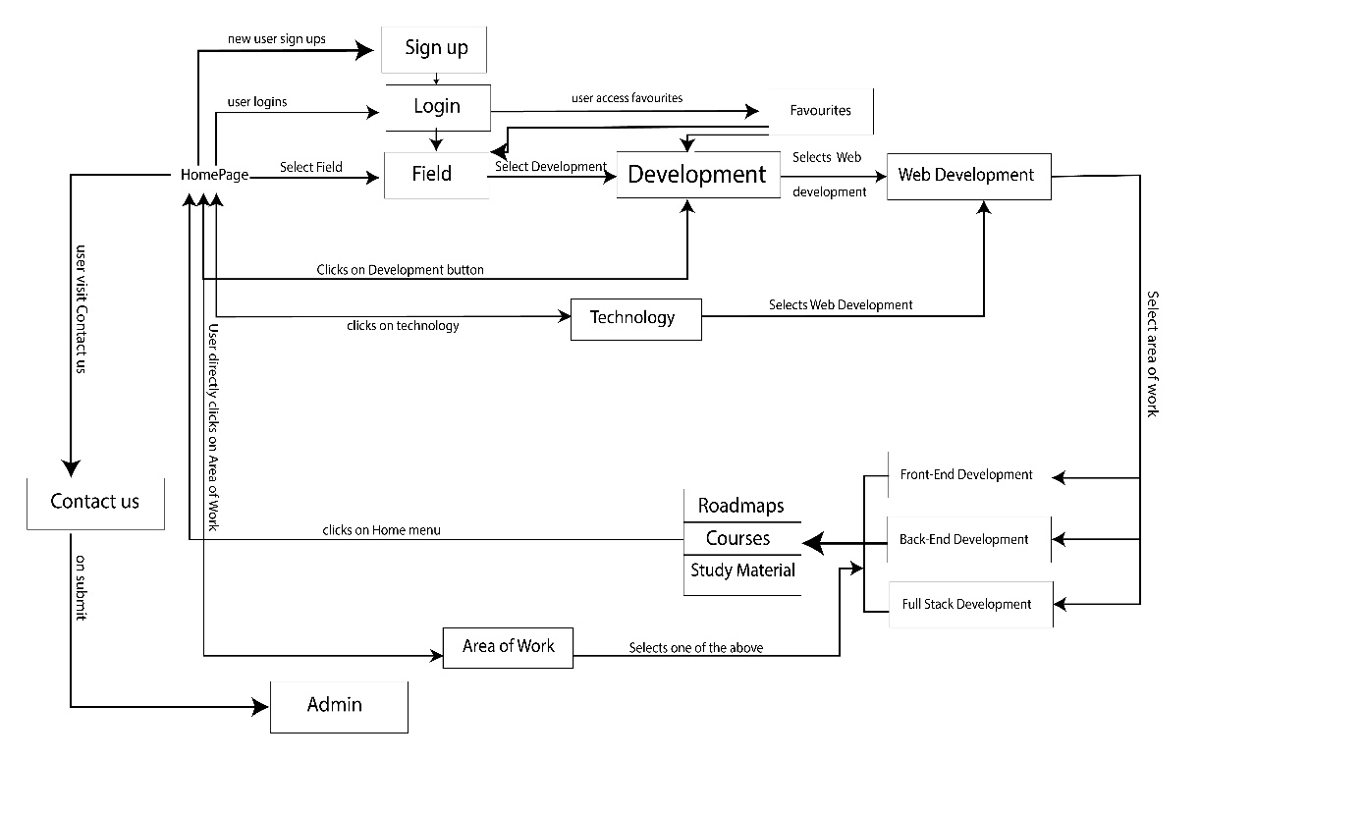

# Elements in the Functional Modules:

# Field

# Technology

# Area of Work

# Contact us

# Login

# Sign up

# Field Module

# Field Module lists the various types of career fields such as Development, Graphics Designing, Software Testing, Networking Engineer, Hardware and IT and many more. You can select the field from the given options in which you want to build your career.

# Technology Module

# Technology Module is a subcategory of the Field Module. It lists the various kinds of technologies under the fields mentioned above such as Web Development, App Development, Java Developer, Python Developer, Machine Learning, Artificial Intelligence, Designing, Motion Graphics and Animation, Manual and Automation Software Testing and many more. You can choose your technology in which you want to move ahead in your career according to the chosen field at the first step.

# Area of Work Module

# This Module is a subcategory of the Technology Module. It helps you choose a right area of the different technologies as mentioned above such as Front End, Back End or Full Stack, Vectors and Illustrations in 2D or 3D, Animation and Motion Graphics in 2D or 3D, 3D Modelling or Character Designing, Selenium with Python or JAVA, Database Testing, GUI Testing, Penetration Testing, Performance Testing and many more. You can choose the right area of work as per your above chosen technology and field. It will provide you all the necessary information and Roadmaps and also the resources available to learn the technologies.

# 

# Contact us Module

# Contact us Module allows end users to send queries to the admin for any support regarding course materials, roadmaps, guidance and any other technical information or study material.

# Login Module

# Login Module allows users to login to the career roadmaps and become a verified and known user to the career roadmaps which helps them to save their favorite courses, technologies and roadmaps and other study material.

# Sign up Module

# Sign up Module is for new users to become a partner to career roadmaps for a better future, registered users gets more perks and advantages as compared to regular users like favorite courses, roadmaps, study material and much more.

**DFD Diagram**

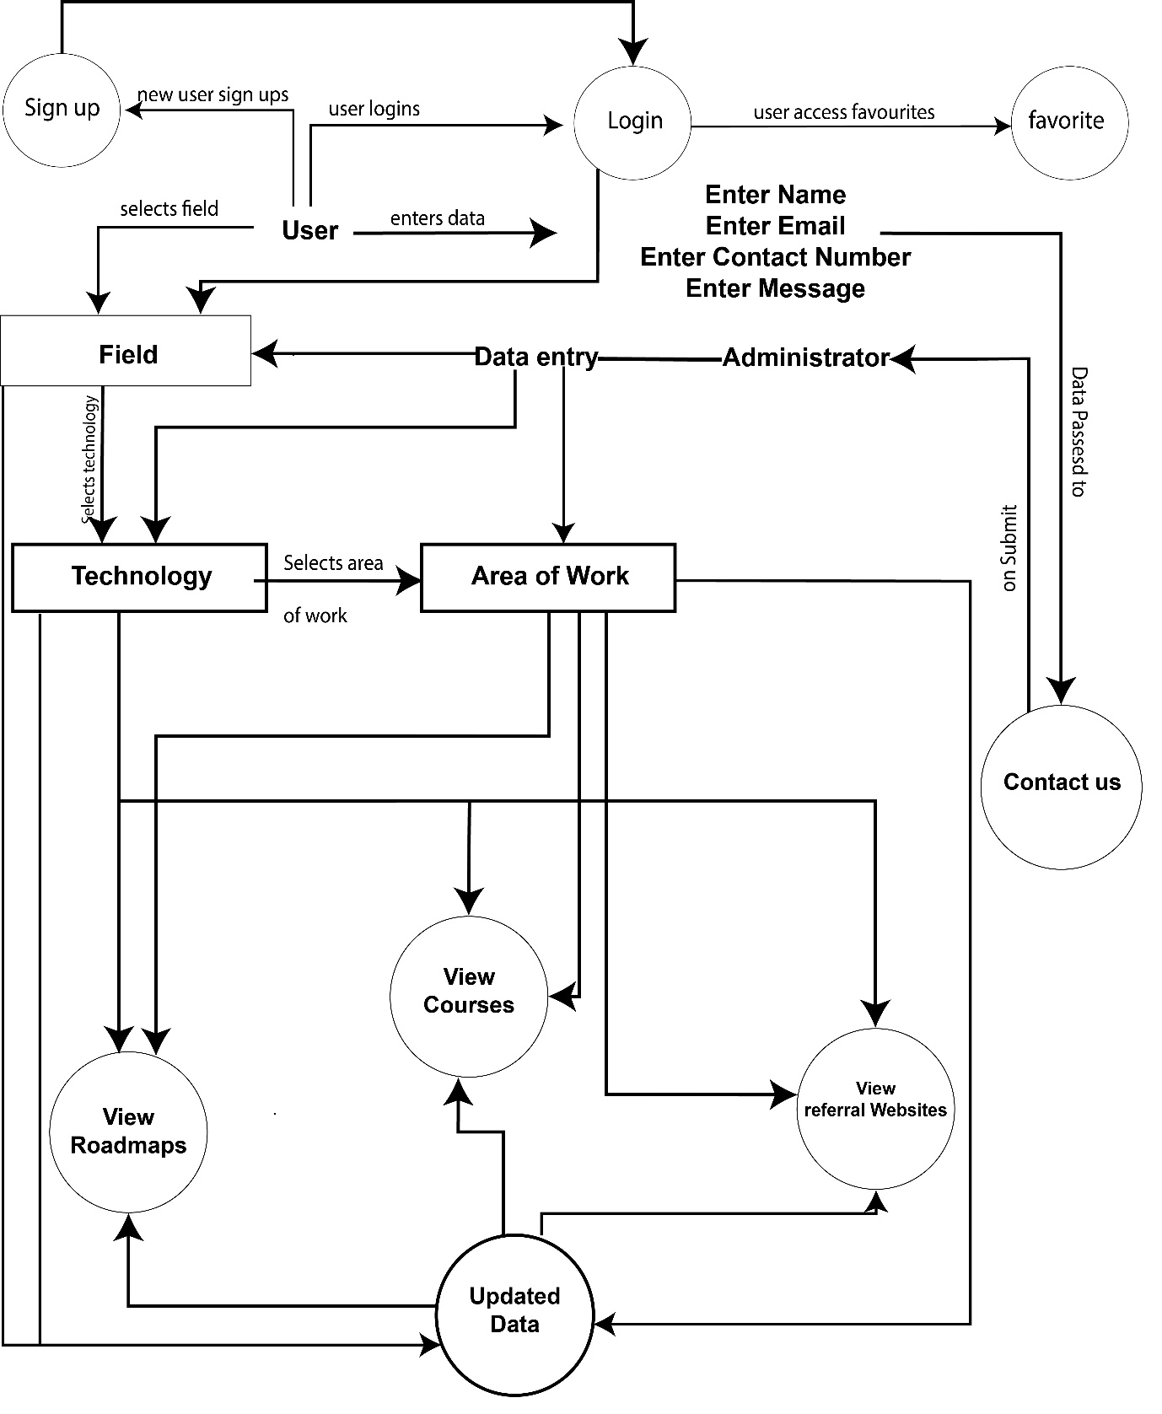

**Gantt Chart:**

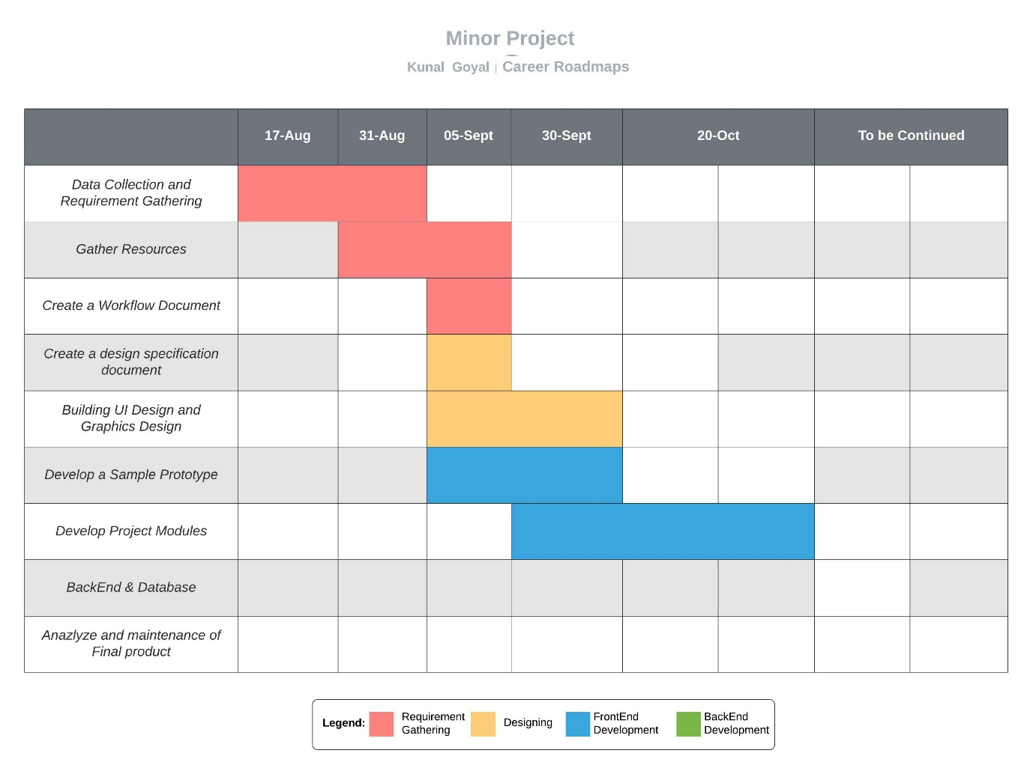

**Interface Design**

1. **Output Design**

**Career Roadmaps Homepage with Heading Navbar Menu**

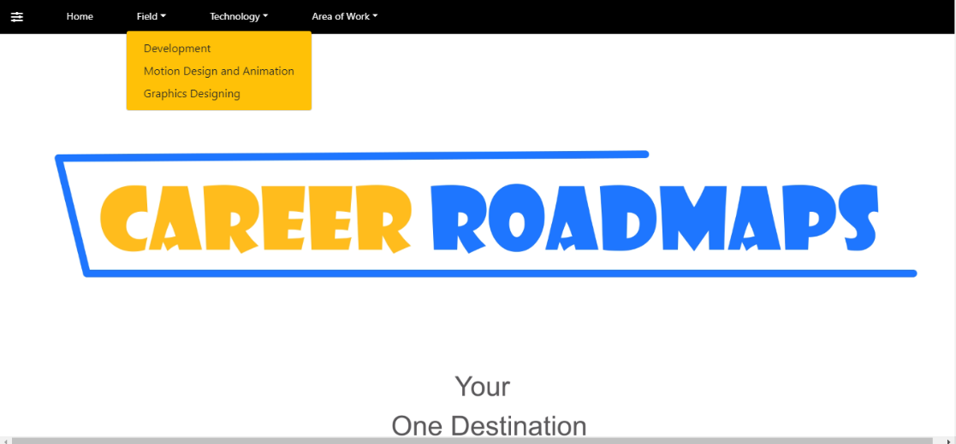

**Career Roadmaps Homepage with Bottom Collapsed Menu**



**Career Roadmaps About Us Section**



**Career Roadmaps Contact Us section**

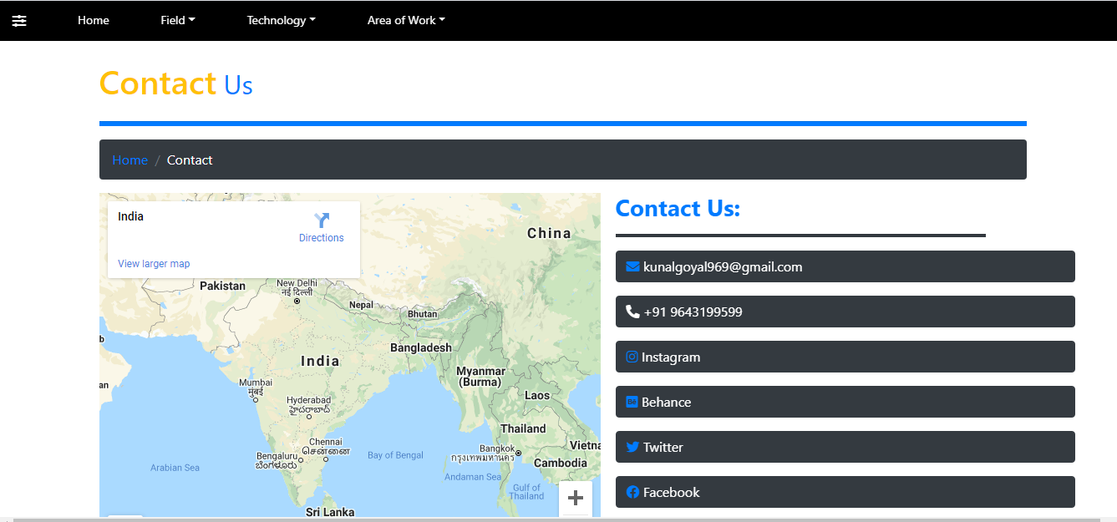

**Career Roadmaps Login section**

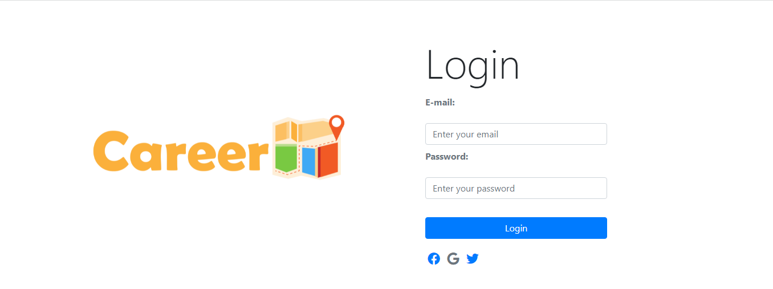

**Career Roadmaps Sign Up section**

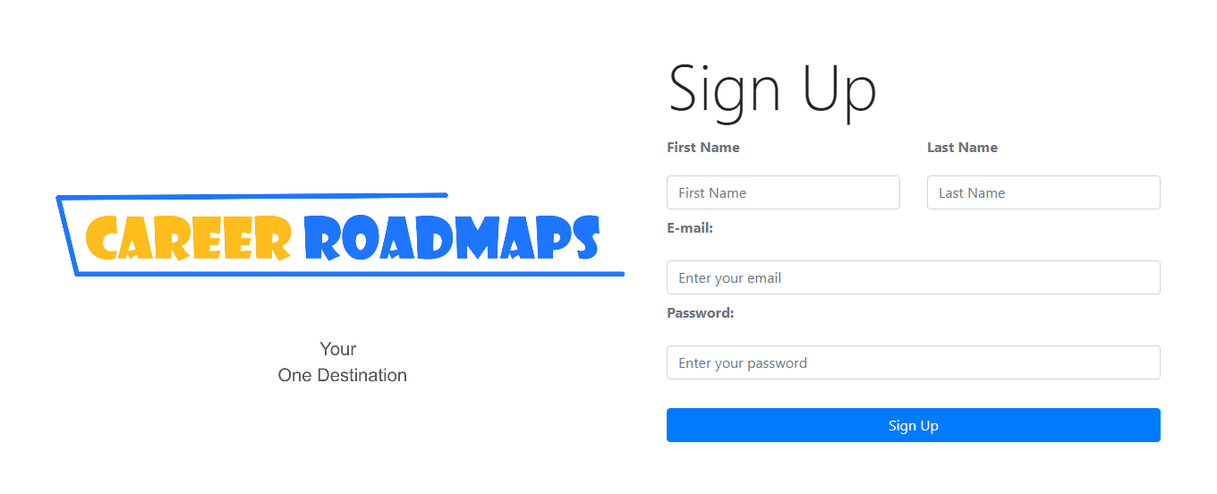

**Career Roadmaps Web Development section**



**Career Roadmaps App Development section**

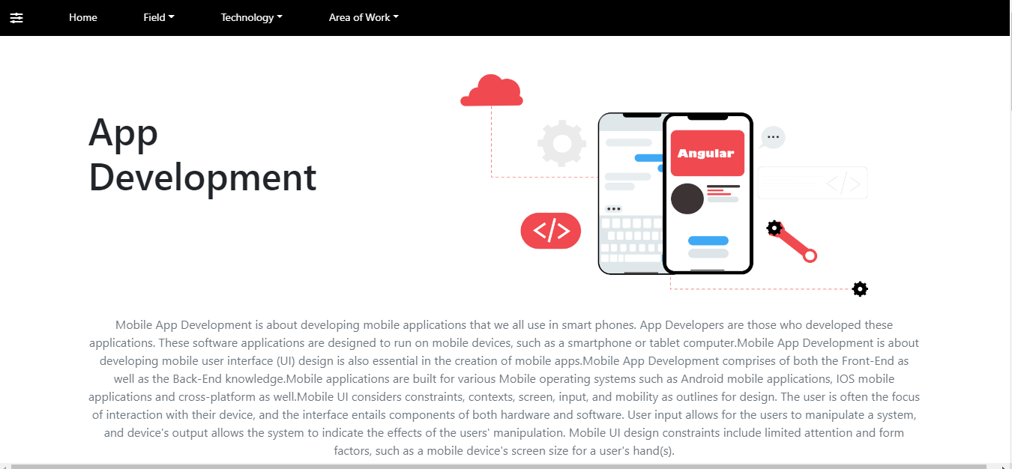**Career Roadmaps Full Stack section**

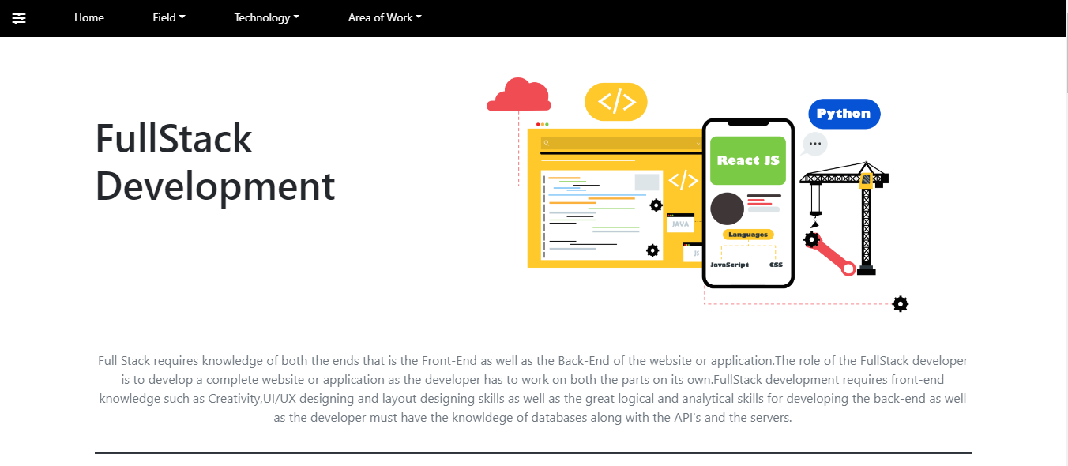

1. **Input (Form or Screen) Design**

**Login Form (with validation checks):**

**Email validation checks:**

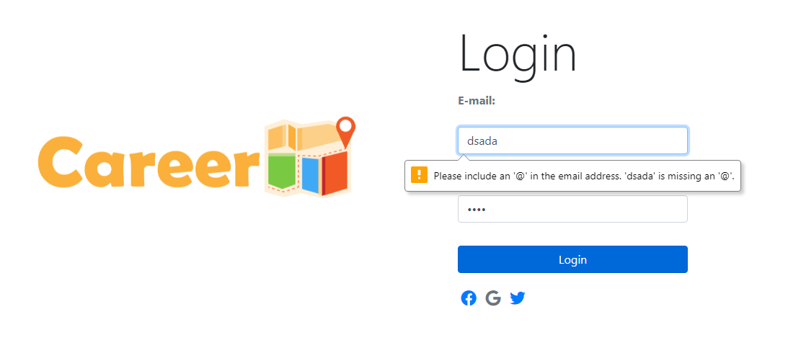



**Password validation checks:**



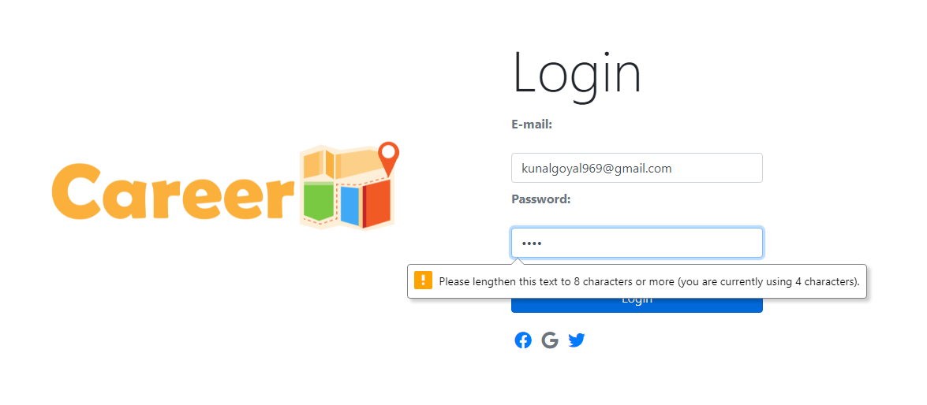

**Sign Up Form (with validation checks):**

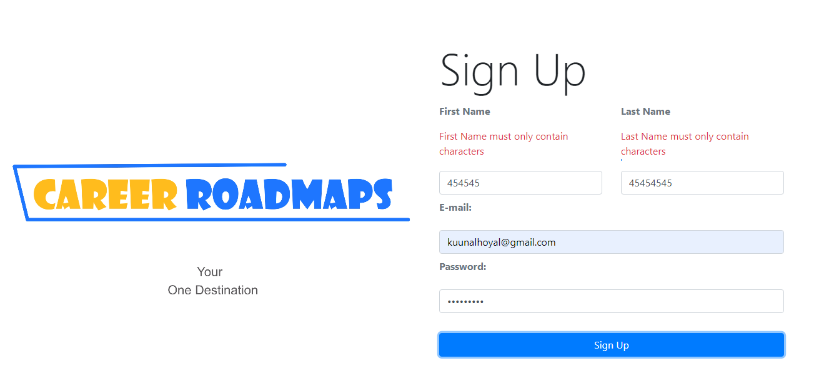

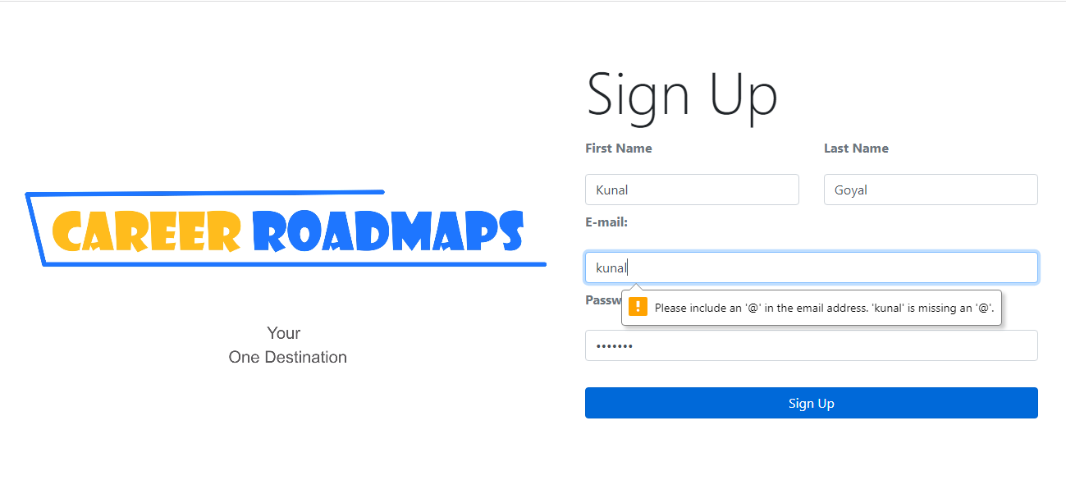

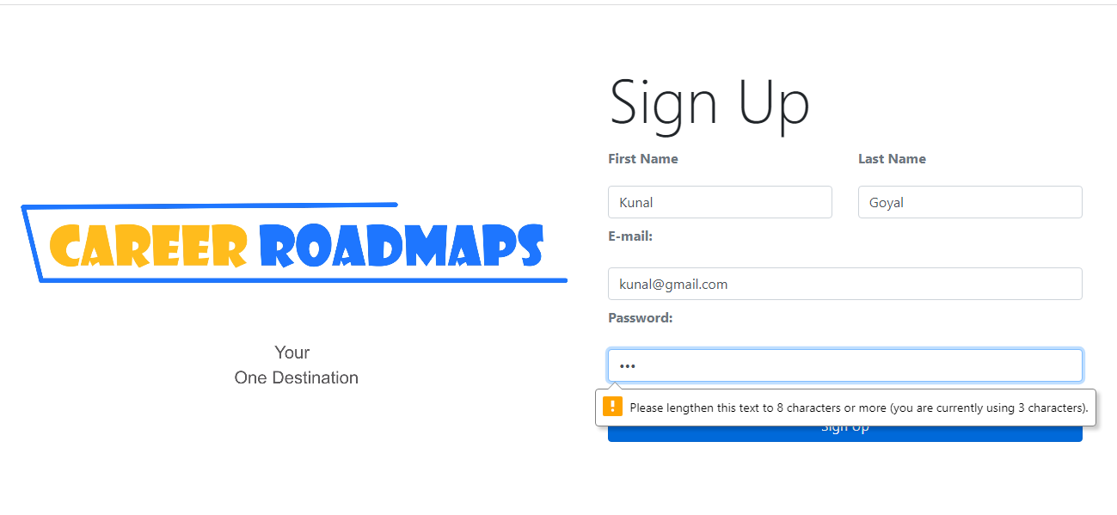

**Contact us Form Design (with validation checks):**

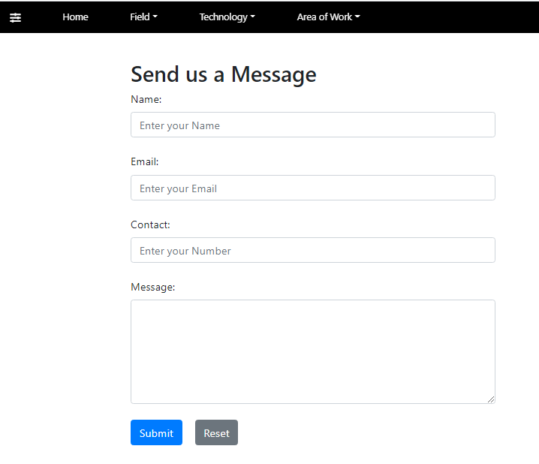

**Validation Rules for Name Field:**

1. **Name is a mandatory field it must be filled by the End-user else a validation message comes with a red mark (Please Enter a Name).**

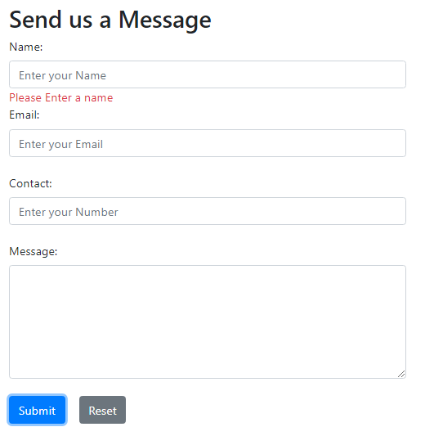

**2.Name must be in the range of 3-12 characters else a validation message is displayed (Name must be in the range of 3-12 characters)**

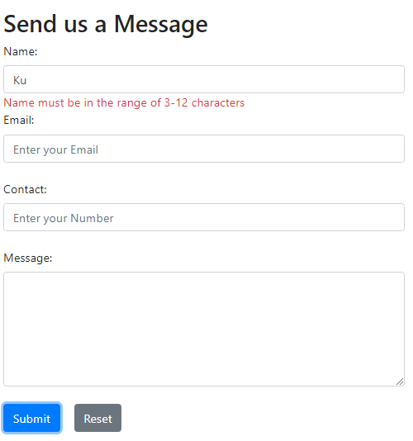

**3.Name field must only contain characters without any digits else a Validation message is displayed (Name must only contain characters)**

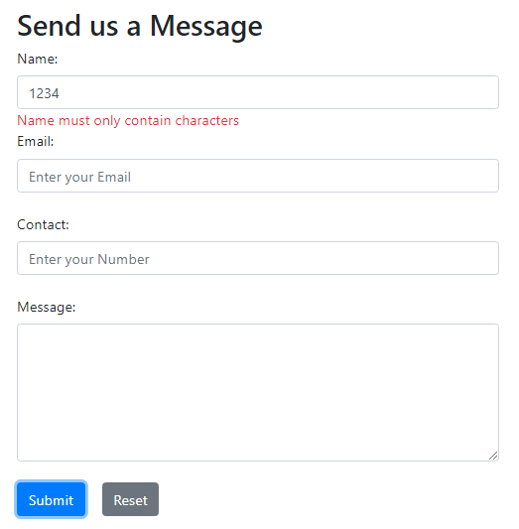

**Validation Rules for Email Field:**

**1. Email field is a mandatory field else an error validation message is displayed (Please Enter an Email)**

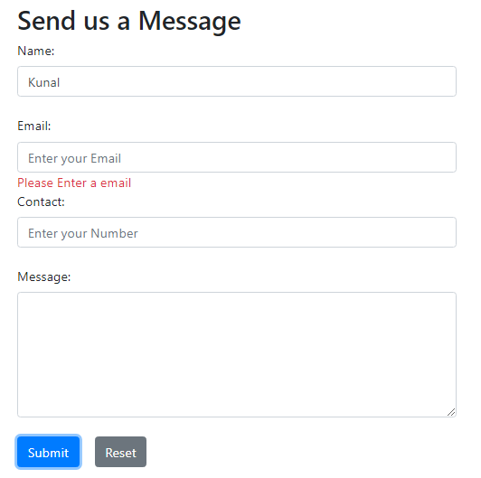

**2.Email entered by the end user must be a valid email and must consist of ‘@’ symbol and ‘domain-name.com’ else an error validation message is displayed (Invalid Mail).**

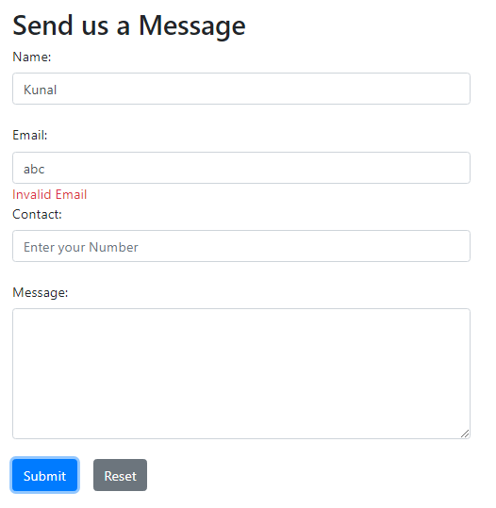

**Validation Rules for Contact Number Field**

**1.Contact Number is a mandatory field else an error validation message is displayed (Please enter a Contact Number)**

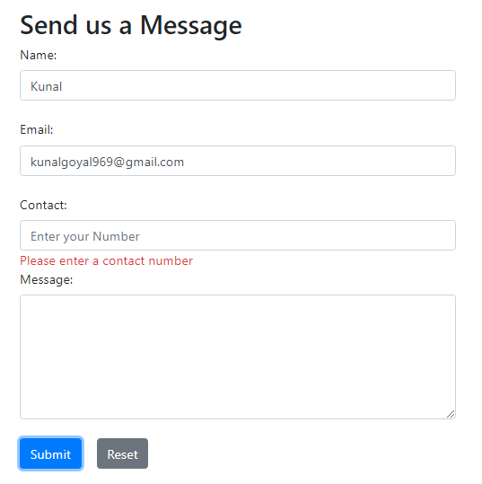

**2.Contact Number field must only contain digits and not characters else an error validation message is displayed (Contact must only contain Numbers).**

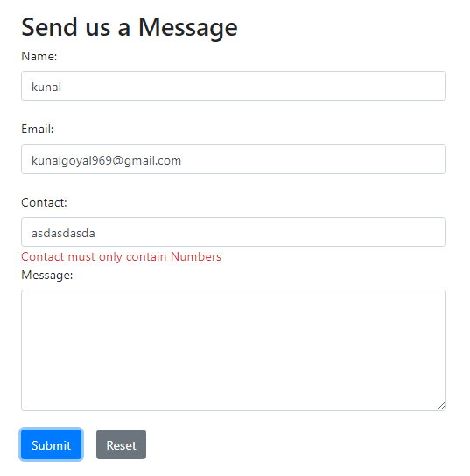

**3.Contact field must contain a contact number of 10 digits else an error validation message is displayed (Contact must be of 10 numbers).**

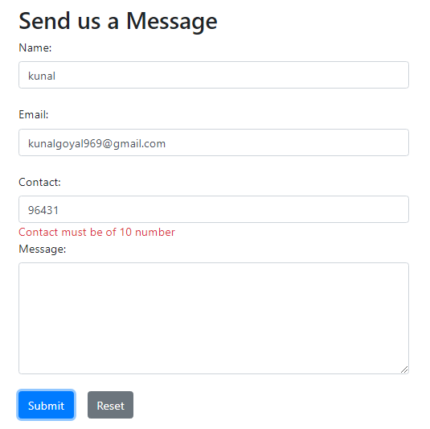

**Login Form (with validation checks) code:**

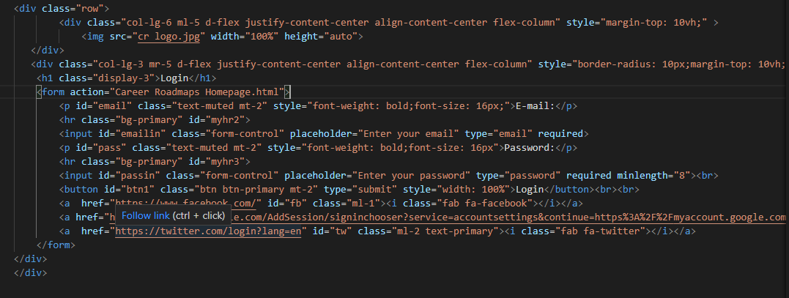

**Sign Up Form (with validation checks) code:**

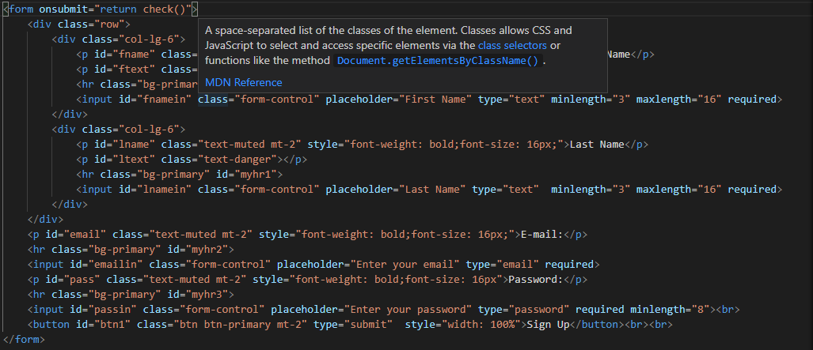

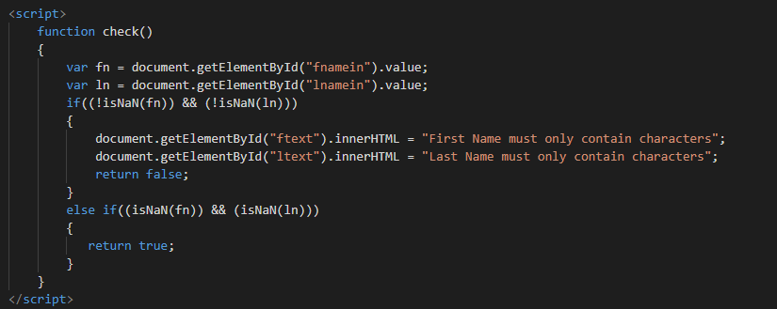

**Contact Us Form (with validation checks) code:**

